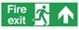

Fire Emergency Evacuation Plan
Wood Lane Primary School 2026 (Review date: Sept 27)

This document details the fire and emergency evacuation procedures for these premises. Staff must ensure they are familiar with these procedures and act upon the requirements.

Premises Plan
Staff and visitors have a responsibility to ensure that they are familiar with the premises plan. This will show marked fire exit points, the location of firefighting equipment and the routes to be followed in an evacuation. There is one available in each room.

Action on discovering a fire
Upon discovering a fire, the person should
- Trigger the fire alarm by breaking one of the call points which are located around the school- please see the premises plan for precise locations.
- Call the fire and rescue team on 999 immediately. The alarm will trigger a continuous ring to signal to all that evacuation should take place immediately.

Summoning the fire and rescue service
- The person who triggered the alarm will summons the Fire and Rescue Service, via the nearest phone available to them (all classes have access to a phone, one if located in the kitchen, staff room and in the Headteacher’s office and main office). In the event of an emergency, a staff member can use their mobile phone if this is available to them, to call 999.

Action when the fire alarm sounds
- Staff in charge of a whole class (teachers/supply/TA’s) will calmly tell the children to stop what they are doing, line up silently and leave the building via the evacuation route. This will be done under the direction of the teacher/TA.

- Children will walk quickly and silently to the nearest exit point.

- Each member of staff in charge of a class will grab the fire pack from the classroom as they exit the room, then close the door. Use this to complete a roll call/headcount as the assembly point.

- All classes will assembly at the designated assembly point on the main yard, in the corner of the playground, furthest away from the main building and the EYFS building. Take a roll call/headcount and identify missing children/individuals.

- Children with 1:1 support will be supported by a member of staff on a 1:1 basis, to evacuate the building via the nearest exit route and they will escort children to the assembly point.

- A member of the office staff will take the pupil sign in/out register on exiting the building. Office staff will exit via the main entrance and member of office staff will open the main access green gate, onto the yard to let the fire service onto the grounds. Complete a register check. If the office staff member is around school at the time the alarm is sounded, they will head straight to open the gate and the HT will take the pupil sign our register out.

- The HT/office staff will take the mobile phone with the visitor/staff sign in and out and check who is at the evacuation point.

- Alert the fire service of any missing adults or children.

Designated roles and responsibilities (when staff are not allocated to whole class teaching)

SF will check the staff toilets, offices, medical room, staff room and exit via the main entrance, then proceed to the assembly point. If SF is not in, one of the office staff will be given this responsibility. SF will check the Year 6 boy’s toilets, the corridor walkway and the library (old Year 6 classroom)

SD will check Elms (HT’s office and the disabled toilet then leave the building via the nearest evacuation route and proceed to the assembly point with his class.

GS will check the kitchen, the Key Stage One toilets, the hall, the KS1 Classroom and then leave the building via the nearest evacuation route and proceed to the assembly meeting point. (The kitchen staff will support this area also if they are in).

SM will check the EYFS classroom toilets and leave via the nearest evacuation route and proceed to the assembly point.

If the caretaker is in school, he will ensure final checks are made before evacuating via to the nearest evacuation route and proceeding to the fire meeting point.

Lunch time supervisors will lead children out of the hall, via the nearest evacuation route and proceed to the assembly point.

DD will check the kitchen area to ensure everyone has left via the nearest evacuation route. (DD will support checking the hall, KS1 classroom and toilets also).

The catering assistant will exit the building by the nearest evacuation route and will join all other staff at the assembly point on the yard.

If at any time there are no additional adults to check other areas due to low staffing in school, the staff working with the class will get all children out and if a child appears to be missing, this will be reported to the HT and or fire service.

Flexible Allocation of Fire Safety Responsibilities
As a small village school, staffing levels can vary from day to day due to staff absence, leave, training and other operational requirements. Fire safety responsibilities are therefore shared and flexible and are not dependent upon one particular individual being present.

The School recognises that staff roles may overlap and that, where a member of staff is absent, another suitably available member of staff may need to take on their fire safety responsibilities. All staff are expected to understand the School’s fire evacuation procedures and to be prepared to support colleagues and undertake additional responsibilities when required.

The Headteacher and Premises Manager have overall responsibility for coordinating fire safety arrangements and, where necessary, will allocate or reallocate duties according to the staff available on the day. Where the Headteacher or Premises Manager is unavailable, the most senior member of staff present will coordinate the evacuation and allocate responsibilities as appropriate.
Teachers and Teaching Assistants are Fire Marshals and will work together to support the safe evacuation of pupils, staff and visitors. Fire Marshal duties may be shared between available Teachers and Teaching Assistants and may be adjusted according to staffing levels and the circumstances at the time.

The Caretaker, Office Staff, Teachers, Teaching Assistants/Fire Marshals and Other Staff will work together to ensure that all areas are evacuated safely, pupils and visitors are accounted for, registers are checked, fire routes remain clear and the appropriate emergency services are contacted when required.

All staff should be familiar with the school’s fire evacuation arrangements and should not assume that a particular duty will always be undertaken by a particular person. Staff may be required to step into another role or assist a colleague where staffing levels or absence make this necessary.

No member of staff should delay their own evacuation or place themselves at risk in order to undertake a fire safety duty. Where a designated person is absent, their responsibilities will be covered by another available member of staff as part of the School’s shared approach to fire safety.

The overriding priority in all circumstances is the safe and timely evacuation of pupils, staff and visitors.

Accessibility Needs

Children in wheelchairs or who have mobility issues will have specific care plans which outline their access and evacuation arrangements in the event of a fire. When drawn up for specific children, they will be shared with all staff and designated staff will be given responsibility to support these children, in the event of a fire breaking out. (See individual plans).

Any staff member/child or visitor/volunteer that has a medical condition/impairment such as a hearing loss will have a specific risk assessment put into place for them. Where there is hearing loss, the individual will be paired up with another member of staff, who will alert them that the fire alarm has been evacuated and that they should leave the building via the nearest exit.

At the fire evacuation designated assembly point
Roll Call/Headcount
The member of staff with responsibility for each class will check that all children are present, by conducting a roll call. They will hold a green sign up if all are accounted for and a red sign if there are any missing children.

Any absent children known to be absent on that day, must have been accounted for via contact with parents at the start of the day or after the pm register. If a child identified as missing at the roll call/headcount and is known to be in school (as identified by the morning/pm register and has been visually seen to be presence in school by their teacher/staff, this will be communicated immediately to the HT and Office. The last known whereabouts will be identified, and their details and a description will be given to the fire service, who may need to enter the building to find the individual.

It is important that all staff, visitors, volunteers, governors sign in and out of school, daily or when visiting. This is to be done via the electronic Ipad system in the front office or APP.

The office staff/Headteacher will ensure that all staff, visitors, volunteers, governors etc are accounted for. Anyone identified as missing, will be made known to the fire service, so that they can conduct a search for the individual (full name and description to be given). Their last known whereabouts will also be given for the purpose of the fire crew entering the building to complete a search for the individual.

Attendance in class card
Each day a staff member from each classroom will fill in the class attendance card, outlining the number of pupils in attendance and the number of staff in attendance.
They will initial any missing children on the card or any staff member initials who are absent.

If a child or staff member goes home for any reason, staff must update this in light of the change in numbers.

This card will be on display by the fire pack and will be taken out with the staff member in charge of the class, upon evacuation of the classroom.

Disciplinary action may be taken, if this is not completed and kept up to date by the staff member in charge of the classroom.

Training

Fire Marshals- Receive training via The National College and all other staff will complete fire awareness training. The Headteacher/caretaker will complete a higher level of training.

Staff Absences
In the event of staff absences, or TA’s, the caretaker will take on their role and the headteacher will take on additional areas for checking. In the vent there are limited staff, then all children will be evacuated and missing children/staff will be reported to the HT and fire service who will decide if it is safe to enter to building to retrieve the missing individual.

Fire drills
Fire drills are undertaken termly, as a minimum. They are recorded in the Fire Logbook, along with actions from the previous meeting. Actions are communicated with staff during staff meetings and or staff briefings.

Visitors and contractors
Upon arrival, visitors and contractors sign in at the reception. Office staff will ensure that visitors are aware of the fire procedures and assembly point. The above will apply to visitors and contractors should they discover a fire or need to evacuate.
Upon evacuation they should report the office staff/HT and the assembly point.

Fire alarm test
6 monthly service by Lantern Fire and Security. Weekly call point testing will be undertaken by the Caretaker/designated adult.

All staff, pupils, visitors, contractors, guests will follow this simple guidance, on the posters around school. Whilst doing that, Fire Marshals will take on their designated roles.

Staff, pupils, visitors, guests, contractors will take note of these signs around school.

Staff will also use the fire evacuation floor plan to know where the exits are within the building. This will be shared with anyone new to the setting.
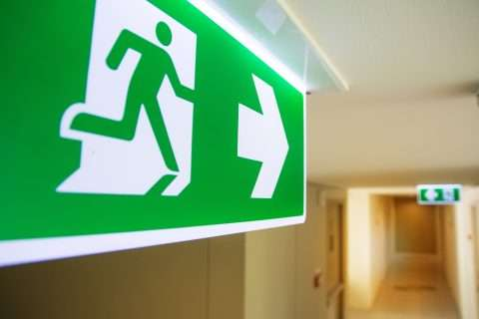
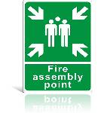

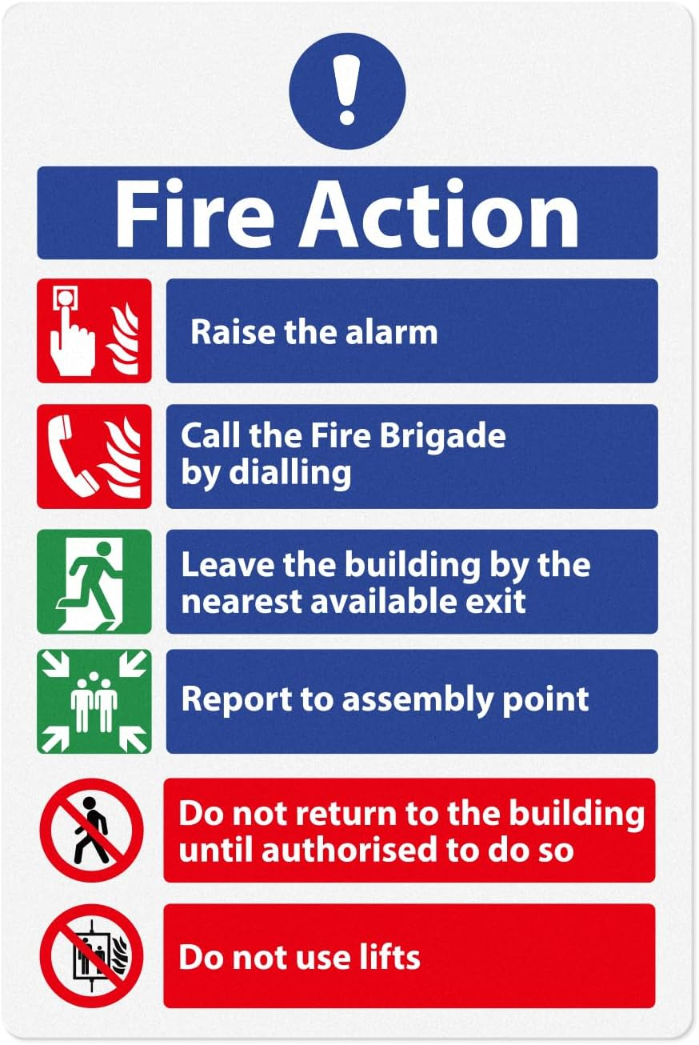

Attendance today in class

Number of pupils in school today: (add number and initials)

Number of staff working in the room today: (Add number and initials)

Absent children today: (add number/initials)

All
Pupils Present
Card

Missing Pupils
Alert
Card

Attention Fire Crew
Fire floor plan displayed on the opposite wall.

