Wood Lane Primary School

Allergy Policy

September 2026



Be the best version of yourself!

Contents
- Key contacts
- Statement of intent
- Equalities statement
- Context
- Principles
- Allergy management checklist
- Practical steps
- Supply, storage and care of medication
- Catering
- Allergy awareness and nut bans
- Risk assessment
- Training
- Allergies and bullying
14. Legal and compliance framework
- Appendices

1. Key contacts
Role | Name / contact details
Headteacher | Mrs Samantha Fraser
Member of staff responsible for medical needs | Mrs Samantha Fraser
Chair of governors / trustees | Acting point of contact: Mr Andrew Buckley
School office | 01782 720487  office@woodlane.staffs.sch.uk
Catering manager / provider | Catering Assistant: Mr Daniel Davies, food supplied and prepared by James Bateman High School, Biddulph

2. Statement of intent

Wood Lane Primary School is committed to promoting a whole-school approach to health care, welfare and wellbeing, and the safe management of those members of our school community who live with specific allergies. We believe that all allergies should be taken seriously and dealt with in a professional and appropriate way. The school recognises that allergies can be serious and potentially life-threatening. It is committed to providing a safe, inclusive environment in which pupils with allergies can participate fully in school life. The school will work in partnership with pupils, parents and carers, health professionals, staff and governors, and the catering provider to reduce risk, respond appropriately to allergic reactions, and promote awareness across the school community.
By our actions we will work proactively to:
• Minimize the risk of exposure within the school setting
• Encourage self-responsibility
• Learn avoidance strategies
• Have robust plans for an effective response to possible emergencies
• Ensure inclusivity for all pupils

3. Equalities statement
The school will make reasonable adjustments for pupils with allergies and will take steps to ensure they are not disadvantaged, excluded, stigmatised, or subjected to bullying because of their condition.
Wood Lane Primary is clear about the need to actively support pupils with medical conditions. The school will consider what reasonable adjustments need to be made to enable these pupils to participate fully and safely in all aspects of school life. Risk assessments will be carried out so that planning arrangements take account of any steps needed to ensure that pupils with medical conditions are included. In doing so, pupils, their parents, and any relevant healthcare professionals will be consulted.

4. Context
Food allergies are increasing in both developed and developing countries, especially in children, and the severity and complexity of food allergies is also increasing. Food allergies can be fatal, and an appropriate diagnosis is essential in parallel with the need for clear food labelling worldwide. Around 5 – 8% of children in the UK live with a food allergy and most school classrooms will have at least one allergy pupil. These young people are at risk of anaphylaxis, a potentially life threatening reaction which requires an immediate emergency response. 20% of severe allergic reactions to food happen while a child is at school, and these reactions can occur in children with no prior history of food allergy. It is essential that staff recognise the signs and symptoms of an allergic reaction, and are able to manage it safely and effectively. Schools have a legal duty to support pupils with medical conditions, including allergies. An allergy is an abnormal immune response to a substance that is normally harmless. Reactions can range from mild symptoms to anaphylaxis, a severe and potentially life-threatening reaction requiring immediate treatment.
Effective allergy management depends on accurate information, individual planning, staff training, safe food practices, access to medication, and a clear emergency response.

5. Principles
- Comply with all relevant environmental legislation, regulations, and requirements
- Encourage proactive steps to keep pupils safe
- Ensure pupils from diverse backgrounds, ethnicities, or cultural heritages are not disadvantaged when dealing with allergies and food labelling
- Work with the catering provider to establish a robust process and documentation for menu planning, food labelling, food storing, avoidance of cross-contamination, and stock ordering of consumables used at the school
- Provide an effective staff awareness programme about food allergies and intolerances, recognition of potential symptoms (anaphylaxis), and actions to take
- Develop a pupil awareness programme through PHSE and other curriculum areas
- Identify pupils with known allergies and maintain accurate, up-to-date records.
- Develop an individual healthcare plan where required, in partnership with parents or carers and relevant health professionals.
- Ensure staff understand allergy risks, recognise symptoms, and know what to do in an emergency.
- Keep prescribed medication accessible, in date, appropriately stored, and clearly labelled.
- Work with the catering provider to establish robust processes and documentation for menu planning, food labelling, food storage, avoidance of cross-contamination, and ordering consumables used at the school.
- Plan for lessons, trips, clubs, events, celebrations, and other activities where allergens may be present.
- Promote inclusion and challenge allergy-related bullying or unsafe behaviour.

6. Allergy management checklist
- Allergy information is collected at admission and reviewed when circumstances change.
- The pupil's healthcare plan and emergency action plan are available to relevant staff.
- Consent and instructions for administering medication are recorded.
- Medication is correctly labelled, accessible, and checked regularly for expiry.
- Relevant staff have received appropriate training.
- Catering staff have current information about pupils with food allergies.
- Risk assessments cover the classroom, dining areas, trips, clubs, and special events.
- Emergency contacts and procedures are clear and readily available.
Allergy checklist to be used in school
- Does the child have an Individual Healthcare Plan?
- Has your school purchased spare pens?
- Does each child have a completed and signed Allergy Action Plan?
- Have all school staff been trained in allergies and anaphylaxis?
- Does the school Allergy Policy include where and how to store AAIs?
- Is there a schedule to check the expiry dates on spare AAIs and each child’s AAI?
- Does the Allergy Policy cover catering for children with allergies?
- Does the Allergy Policy include pupil allergy awareness?
- Has the school completed an allergy risk assessment?
- Does the Allergy Policy include risk assessment of extra curricula activities?
- Does the Allergy Policy cover safeguarding children with allergies, including bullying?

7. Practical steps

7.1 Governors and trustees
Ensure allergy-related arrangements are reported to the governing body and the policy remains effective and fit for purpose.
Ensure records of pupils medically prescribed an adrenaline auto-injector (AAI), supporting documentation and in-date medication are maintained correctly.
Ensure first-aid training includes anaphylaxis management, awareness of triggers and emergency procedures.
Ensure there are enough trained staff to meet pupils’ assessed needs, including arrangements for staff absence.
Encourage parents/carers to provide an Allergy Action Plan (AAP) completed and signed by a healthcare professional, kept with medication, with copies available to relevant staff.
Ensure pupil medical details are reviewed with parents/carers and updated when circumstances change, including at least annually and when a pupil joins or is newly diagnosed.
Ensure a workable School Emergency Plan is in place and known by staff.
Ensure the curriculum includes age-appropriate learning about allergies, how to avoid risks, and how pupils can support classmates safely.
Ensure visitors, volunteers, work-experience pupils and sub-contractors are made aware of the school’s allergy-management arrangements where relevant.
Ensure allergy management is treated as part of safeguarding and that strategic arrangements for risk assessment and emergency procedures are robust.

7.3 Members of staff responsible for medical needs
Record all emergency uses of AAIs and suspected emergencies. If a pupil reports that an allergy has resolved, verify this before changing the school’s records or healthcare plan.
Maintain an audited spare supply of in-date AAIs, stored securely but not locked away, at room temperature, with all staff aware of the location.
Where medication is stored by school, use a rigid, clearly labelled container with the pupil’s name and photograph; older pupils may carry their own AAIs where appropriate.
If an AAP has not been supplied, or medication information is unclear, seek current information/clarification from the GP or school nursing team.
Where an AAP is used, keep it with the pupil’s medication and ensure copies available around school and on IT systems are identical and up to date.
Work with parents/carers to produce an individual allergy risk assessment covering information-sharing, risk minimisation and emergency actions.
Monitor school tuck shops and home-baked items brought into school where these could introduce allergy risks.
Work with catering managers, including meeting parents/carers where requested, to discuss special dietary requirements.
Lead or coordinate staff training on allergy medical needs, identification and management.

7.4 All staff
A pupil who cannot access required medication must not be permitted to attend an excursion until an effective control is in place.
For trips and off-site activities, check that pupils with medical conditions have their required medication and that relevant emergency supplies are carried by the staff leading the activity.
Supervise food-related activities with appropriate caution and follow good practice for storing, preparing, cooking and serving food.
Be aware of pupils with known allergies, including in regular cover classes, because reactions can occur at any time, not only at breaks or mealtimes.
Raise awareness of allergies and anaphylaxis among pupils, particularly in dining areas, and help pupils understand how to keep classmates with allergies safe.
Complete appropriate anaphylaxis training and be confident to respond to an allergy emergency.

7.5 Parents and carers
Provide two in-date AAIs of the correct dosage where prescribed and register devices with the manufacturer where expiry alerts are available.
Communicate regularly with the school and review arrangements after an allergic reaction.
Be familiar with the school’s Allergy Policy and arrangements for managing allergy and anaphylaxis.
Provide an AAP completed by a healthcare professional and contribute to an Individual Healthcare Plan where required.
Talk with the child about allergy self-management, including safe and unsafe foods, reading food labels, avoiding allergens, recognising symptoms and telling an adult promptly.

7.6 Pupils with allergies
Pupils should tell an adult as soon as they suspect they are experiencing an allergic reaction.
Pupils who are old enough and confident enough to do so should know where their medication is kept and may carry their AAIs on their person in accordance with their healthcare plan.
Pupils should read food labelling but avoid food if they are unsure of its ingredients and should not eat food with unknown ingredients.
When age and capability allow, pupils should develop awareness of their allergy and support peers in understanding how to keep them safe.

See also Appendices one and two)

In order to put these principles into practice we will:

Governors

Ensure the school has a strategic vision for the management of allergy risk assessment and emergency procedures

• Delegate the day-to-day responsibility for the effective delivery of this policy to the Headteacher/H&S Lead

Ensure that the school’s arrangements to identify and safeguard the wellbeing of pupils, due to their own or someone else’s allergies, are robust and effective

Ensure that the school provides appropriate training, information, instruction, induction, and supervision on a regular basis to enable everyone to stay safe regarding allergies and their management; it is good practice to log all training and attendance

Ensure adequate resources for managing allergies are available

Ensure appropriate material is available for parents and carers on the school’s website, highlighting how the school is managing pupils with allergies

Monitor the effectiveness of this policy to ensure it remains fit for purpose

7.2 Headteacher
- Lead implementation of this policy and assign clear responsibilities.
- Ensure systems are in place to identify pupils with allergies and share essential information with relevant staff.
- Arrange appropriate staff training and maintain suitable emergency procedures.
- Ensure allergy risks are considered in school activities and risk assessments.
- Work with parents, carers, health professionals, and catering staff to support individual pupils.

7.3 Members of staff responsible for medical needs
- Coordinate individual healthcare plans and allergy records.
- Check that medication and emergency equipment are available, correctly stored, and in date.
- Share necessary information with staff while respecting confidentiality.
- Keep records of incidents, treatment, and medication administration.
- Support planning for trips, clubs, events, and transitions.

7.4 All staff
- Be aware of pupils with allergies for whom they are responsible.
- Follow individual healthcare plans and emergency instructions.
- Recognise possible symptoms of an allergic reaction and act immediately.
- Never delay emergency treatment while attempting to contact a parent or carer.
- Reduce avoidable exposure to known allergens and report concerns promptly.
- Include pupils safely in lessons, trips, clubs, and school events.

7.5 Parents and carers
- Inform the school promptly about a child's allergy, diagnosis, symptoms, triggers, treatment, and any changes.
- Provide medical documentation, consent, and clear written instructions as directed by a health professional.
- Provide appropriate, in-date medication of the correct dosage, including two adrenaline auto-injectors where prescribed.
- Register adrenaline auto-injectors on the manufacturer's website to receive expiry alerts where available.
- Replace medication after use or upon expiry.
- Meet with the catering manager when required to discuss specific dietary needs; information from these meetings will be recorded by the catering manager.
- Provide suitable food when necessary.

7.6 Pupils with allergies
- Tell an adult immediately if they feel unwell or believe they have been exposed to an allergen.
- Avoid sharing or swapping food and drinks.
- Follow agreed arrangements for carrying or accessing medication, according to age and capability.
- Take increasing responsibility for managing their allergy when developmentally appropriate.

8. Supply, storage and care of medication
Medication must be supplied in its original packaging, clearly labelled with the pupil's name, prescribed dose, and instructions. It must be readily accessible in an emergency and not locked away where access could be delayed.

8.1 Older children and medication
Where agreed in the pupil's healthcare plan and appropriate to their age and capability, older pupils may carry their own medication. The school should also know where the medication is kept and how to access it promptly.

8.2 Storage
- Store medication securely but accessibly, following the manufacturer's instructions.
- Keep emergency medication with the pupil or in a clearly identified, readily accessible location.
- Check medication regularly and record expiry dates.

8.3 Disposal
Used or expired medication must be returned to parents or carers or disposed of safely in accordance with pharmacy or local procedures. Sharps must be placed in an approved sharps container.

8.4 Spare adrenaline auto-injectors
Where the school holds spare adrenaline auto-injectors, they may be used only in accordance with current government and national guidance, parental consent arrangements, and the pupil's medical authorisation. Staff must know where they are stored and how to access them without delay.
Staff will receive training, to ensure they are suitably trained to administer an adrenaline auto-injectors, for both children/adults who have a prescribed pen or for the spare one to be administered where there is an unknown allergy and an emergency occurs.

8. Supply, storage and care of medication
Used AAIs are single-use and should be disposed of as sharps, or handed to ambulance paramedics. Where a sharps bin is used, it should be obtained and disposed of through an appropriate clinical-waste contractor.
AAIs should be stored at room temperature and protected from direct sunlight and temperature extremes.
Parents/carers are responsible for keeping the kit up to date and clearly labelled. The school should check school-held medication termly and remind parents when medication is approaching expiry.
Where applicable, an anaphylaxis kit should contain two AAIs (for example EpiPen® or Jext®), an up-to-date AAP, antihistamine if included on the AAP, a spoon if required, and an asthma inhaler if included on the AAP.
For younger pupils or those not ready to manage their own medication, an anaphylaxis kit should be kept safely, not locked away, and accessible to staff.
Depending on age, understanding and competence, pupils may be encouraged to carry their two AAIs at all times in a suitable bag or container.

9. Catering
The school menu is made available to parents in advance, with ingredients listed and allergens highlighted.
The administrative officer will inform the catering manager of pupils with food allergies.
A photographic list of children with allergies is displayed in the kitchen, office, and staff room, with due regard to confidentiality and safeguarding.
Parents and carers are encouraged to meet with the catering manager to discuss their child's needs.
- The catering provider will follow food-information and allergen-labelling requirements.
- Systems will be used to prevent cross-contamination during storage, preparation, cooking, and service.
- Suitable alternatives will be planned for pupils with medically supported dietary requirements.
- Catering staff will receive appropriate allergy and food-safety training.

9. Catering
Food used in crafts, cooking, science experiments and special events should be considered in advance and restricted or risk assessed where necessary.
Food should not be given to primary-school-age children with food allergies without appropriate parental engagement and permission, including birthday-party treats.
Staff providing food should be trained to read allergen labels and prevent cross-contamination, including careful cleaning of preparation areas and utensils.
If food is purchased from a school canteen or tuck shop, parents/carers should check suitability with the catering manager, and pupils should be taught to check with catering staff before selecting or purchasing food.
Bottles, other drinks and lunch boxes supplied from home for pupils with food allergies should be clearly labelled with the child’s name.
The school menu should be available to parents/carers in advance, with ingredients listed and allergens highlighted.
All food businesses, including school caterers, must provide allergen information for the legally recognised ‘Top 14’ allergens under the Food Information Regulations 2014.

10. Allergy awareness and nut bans
The school will promote allergy awareness and may restrict particular foods where this forms part of its risk-control arrangements. No environment can be guaranteed completely free of an allergen, so any restriction must operate alongside individual healthcare plans, staff training, safe catering procedures, supervision, and emergency preparedness.

10. Allergy awareness and nut bans
Pupils, teachers and other staff should understand what allergies are, the importance of avoiding known allergens, the signs and symptoms of allergic reaction, and how to respond to a reaction.
The school will promote a whole-school culture of allergy awareness rather than relying on a blanket allergen-free environment, recognising that no school can guarantee an entirely allergen-free setting.

11. Risk assessment
The school will assess allergy risks in routine activities and in activities that may introduce additional exposure, including cooking, science, art and craft, food technology, celebrations, fundraising, visitors, breakfast or after-school clubs, residential visits, and off-site trips.
Risk controls will be proportionate to the pupil's needs and documented where appropriate.

11. Risk assessment
Risk assessments should cover routine school life and activities that may introduce additional exposure, including trips, excursions, food activities, cooking, science, art and craft, celebrations, fundraising, visitors, breakfast/after-school clubs and other off-site activities.
A detailed individual risk assessment should be completed for pupils joining the school with allergies and for pupils who are newly diagnosed, to identify gaps in systems and processes.

12. Training
- All staff will receive general allergy-awareness information appropriate to their role.
- Staff who may need to administer medication will receive practical training from an appropriate source.
- Training will cover recognition of symptoms, emergency action, use of adrenaline auto-injectors, calling emergency services, and post-incident procedures.
- Training will be refreshed periodically and when a pupil's needs or treatment change.

12. Training
Training should cover common allergens and triggers; recognition of allergic reaction and anaphylaxis; when to call emergency services; how and when to administer emergency treatment including AAIs; allergen avoidance; roles and responsibilities; associated conditions such as asthma; and keeping AAPs up to date.
Allergy training should include a practical session using trainer AAIs where available.

13. Allergies and bullying
Deliberate exposure to an allergen, threatening a pupil with an allergen, tampering with medication, or mocking a pupil because of an allergy will be treated seriously under the school's behaviour and safeguarding procedures.

13. Allergies and bullying
The school will support pupils with medical conditions so they can participate fully and safely in school life.
Allergy bullying should be treated as seriously as other forms of bullying. Behaviour and safeguarding procedures should be used where pupils deliberately expose another pupil to an allergen, threaten them with an allergen, interfere with medication, or mock or stigmatise them because of their allergy.

14. Legal and compliance framework

14.1 Benedict's Law and statutory allergy safety
Wood Lane Primary School recognises the allergy-safety reforms commonly referred to as “Benedict's Law”. The statutory duties arise from section 34 of the Children's Wellbeing and Schools Act 2026, which amended the Children and Families Act 2014 by inserting statutory provisions concerning allergy safety policies in schools. The school will maintain, publish and review this Allergy Safety Policy at least annually and will have regard to the Department for Education's Allergy safety in schools statutory guidance.
The DfE statutory guidance was published on 6 July 2026 and covers allergy-safety training, Individual Healthcare Plans, adrenaline auto-injector arrangements, and learning from serious incidents and near misses.

14.2 Review and publication
The formal review date for this policy is every July. The July review will consider changes to law and statutory guidance, incidents and near misses, pupil allergy information, IHPs/AAPs, staff training, AAI and inhaler checks, risk assessments, catering arrangements, educational visits and emergency procedures.
The policy will be approved through the school's governance arrangements and published on the school's website. An earlier review will take place after a significant incident or near miss, material change in guidance or school arrangements, or where the policy is no longer adequate.

14.3 Health and safety legislation
Allergy safety forms part of the school's health and safety management system. The school will comply with the Health and Safety at Work etc. Act 1974 and the Management of Health and Safety at Work Regulations 1999, including suitable and sufficient risk assessment, proportionate controls, emergency arrangements, competent oversight, staff information and training, monitoring, recording and review.
Allergy risk assessments will cover classrooms, dining areas, food activities, clubs, trips, residentials, events and other settings where allergen exposure may occur, and will be reviewed after significant change, incident or near miss.

14.4 First aid
This policy operates alongside the school's First Aid Policy and the Health and Safety (First-Aid) Regulations 1981. The school will maintain suitable first-aid arrangements, equipment, facilities and trained personnel. Emergency allergy medicines will be managed through the school's medicines arrangements and will be readily accessible when required.

14.5 Administering Medicines Policy
The storage, administration, recording, checking, replacement and disposal of medicines under this policy will comply with Wood Lane Primary School's Administering Medicines Policy. This includes consent, medical instructions, Individual Healthcare Plans, Allergy Action Plans, staff competence, safe storage, expiry checks, medication records and access during off-site activities.
Emergency administration will be recorded, including the time, device/medicine used, reason for administration and subsequent emergency action, with parents/carers and relevant professionals informed as appropriate.

14.6 Individual Healthcare Plans and Allergy Action Plans
Every pupil whose allergy requires individual management will be considered for an Individual Healthcare Plan in line with current DfE guidance. A healthcare-professional-completed Allergy Action Plan or equivalent emergency plan will be kept with the pupil's medication and made available to relevant staff. Plans will be reviewed at least annually and whenever the pupil's medical circumstances, medication or school arrangements change.

14.7 Spare adrenaline auto-injectors
Wood Lane Primary School will maintain spare adrenaline auto-injectors for emergency use in accordance with current statutory guidance and the school's medicines arrangements. The initial school spare adrenaline auto-injector purchase will be made for implementation from September 2026.
The school-held spare adrenaline pens will be kept in the medical room, at room temperature, in a clearly identified, secure but readily accessible location. They will not be locked away in a way that could delay emergency treatment. The location will be communicated to relevant staff. Spare devices supplement, and do not replace, pupils' own prescribed devices.

14.8 Six-monthly AAI checks and expiry control
A member of the office team or the Headteacher will check the school-held spare AAI kit every six months. The check will record the date, person completing the check, device type/dose, quantity, expiry date, condition, storage and any action required; the record will be kept in the emergency AAI kit/associated record.
New pens will be ordered before the expiry of existing pens to maintain an in-date emergency supply. Used, damaged or expired devices will be dealt with safely in accordance with medicines and waste arrangements.

14.9 Allergy awareness and AAI training
All staff will receive allergy-safety awareness training appropriate to their role, including recognition of allergic reactions and anaphylaxis, emergency response, AAI use, the location and access arrangements for spare devices, allergen avoidance, IHP/AAP arrangements and incident/near-miss reporting. Staff who may administer an AAI will receive practical training appropriate to the devices held by the school.

14.10 Emergency school salbutamol inhaler
Wood Lane Primary School will maintain a school emergency salbutamol inhaler, subject to the applicable medicines arrangements and the Administering Medicines Policy. It will be stored securely but readily accessible, with the appropriate spacer and records, and managed in accordance with current Department of Health and Social Care guidance.
The emergency inhaler does not replace a pupil's own prescribed inhaler or asthma plan. The school's asthma/emergency inhaler protocol will cover eligibility, consent/records, storage, checks, administration, escalation and replacement. Emergency services will be called where symptoms are severe or do not respond appropriately.

14.11 Safeguarding and KCSIE 2026
Allergy management forms part of pupil welfare and safeguarding. The school will operate this policy consistently with Keeping Children Safe in Education 2026, effective from 1 September 2026, and the school's Safeguarding and Child Protection Policy. Staff must consider safeguarding where medication is deliberately withheld or tampered with, a pupil is deliberately exposed to an allergen, or allergy-related bullying, abuse or neglect is suspected.
Concerns will be escalated through the school's safeguarding procedures, with appropriate information sharing, accurate records and involvement of the Designated Safeguarding Lead where required.

14.12 Equality and inclusion
The school will manage allergies consistently with the Equality Act 2010 and its Equality Policy. Pupils with allergies will be supported to participate fully in education, trips, clubs, social activities and events, with reasonable adjustments and proportionate risk controls where required.

14.13 Food safety and allergen information
Catering and food provision will comply with applicable food-safety and allergen-information requirements, including the Food Safety Act 1990 and Food Information Regulations 2014. The school will maintain accurate allergen information, effective communication with its catering provider, prevention of avoidable cross-contact, and suitable arrangements for pupils requiring special diets.

14.14 Incidents, near misses and learning
Serious allergic reactions, AAI use, emergency inhaler use, significant medication errors, suspected allergen exposure and relevant near misses will be recorded and reviewed. The school will identify immediate actions, investigate contributing factors, communicate appropriately with parents/carers and relevant professionals, and implement improvements. Where an incident meets statutory reporting requirements, the applicable reporting route, including RIDDOR where relevant, will be followed.

14.15 Educational visits and off-site activities
No pupil at risk of anaphylaxis will take part in an educational visit, residential, sporting activity or other off-site event without effective arrangements for immediate access to prescribed medication, relevant IHP/AAP, trained/briefed staff and emergency cover. Spare AAIs and other emergency medicines will be carried where required by the risk assessment and current guidance.

14.16 Policy hierarchy
This Allergy Safety Policy must be read alongside the school's Health and Safety Policy, Administering Medicines Policy, Medical Conditions Policy, First Aid Policy, Safeguarding and Child Protection Policy, Equality Policy, Educational Visits Policy and relevant emergency procedures. Where current law or statutory guidance conflicts with an older local procedure, the school will follow the current legal/statutory requirement and update the local policy promptly.

Appendix 1: First aid for anaphylaxis
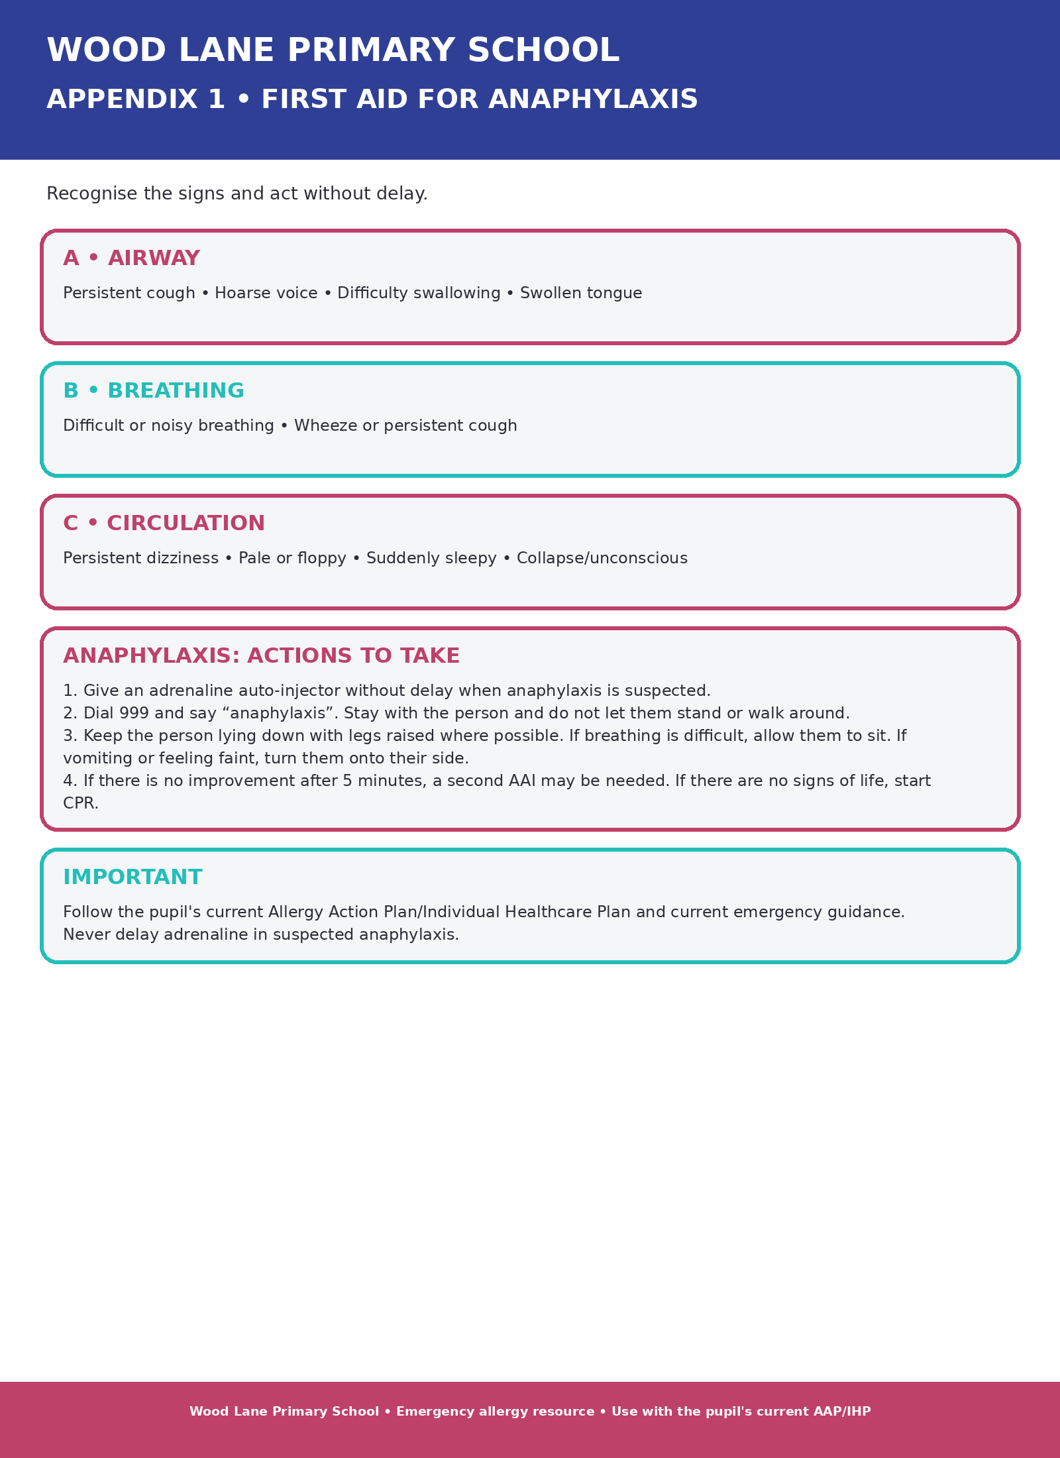

Appendix 2: Adrenaline auto-injector instructions
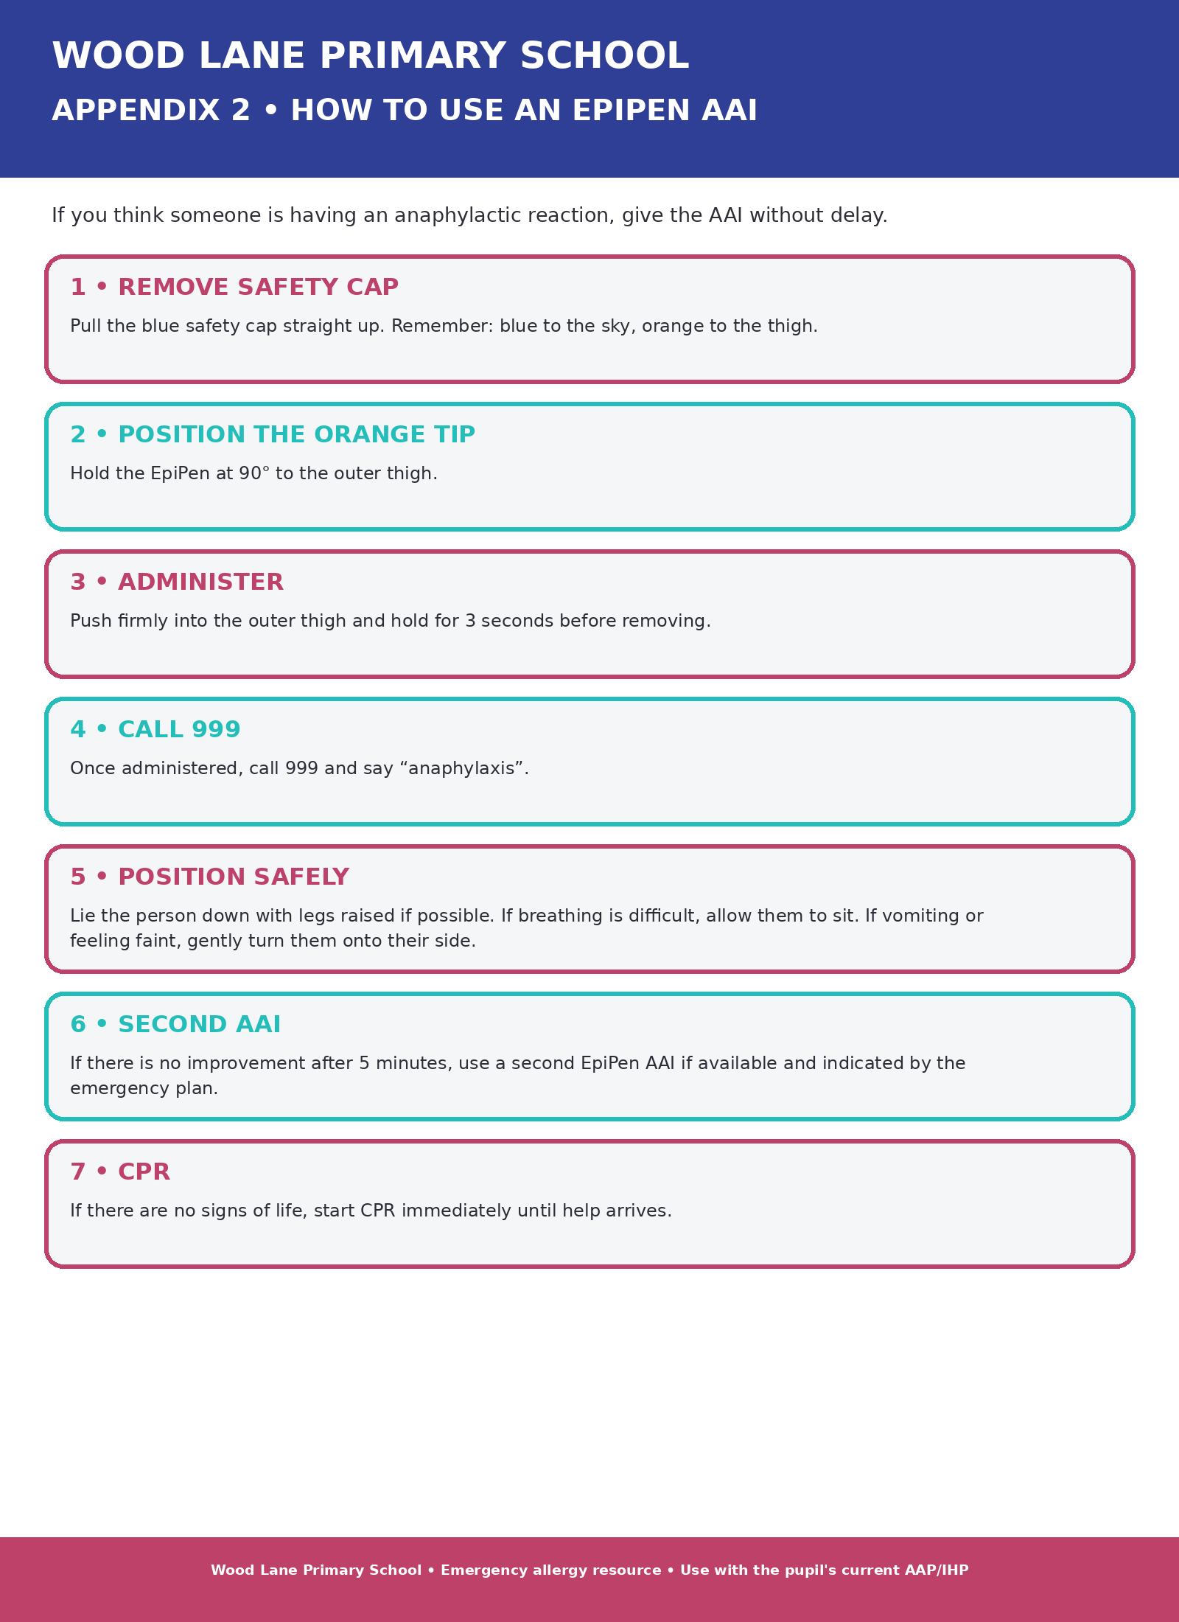
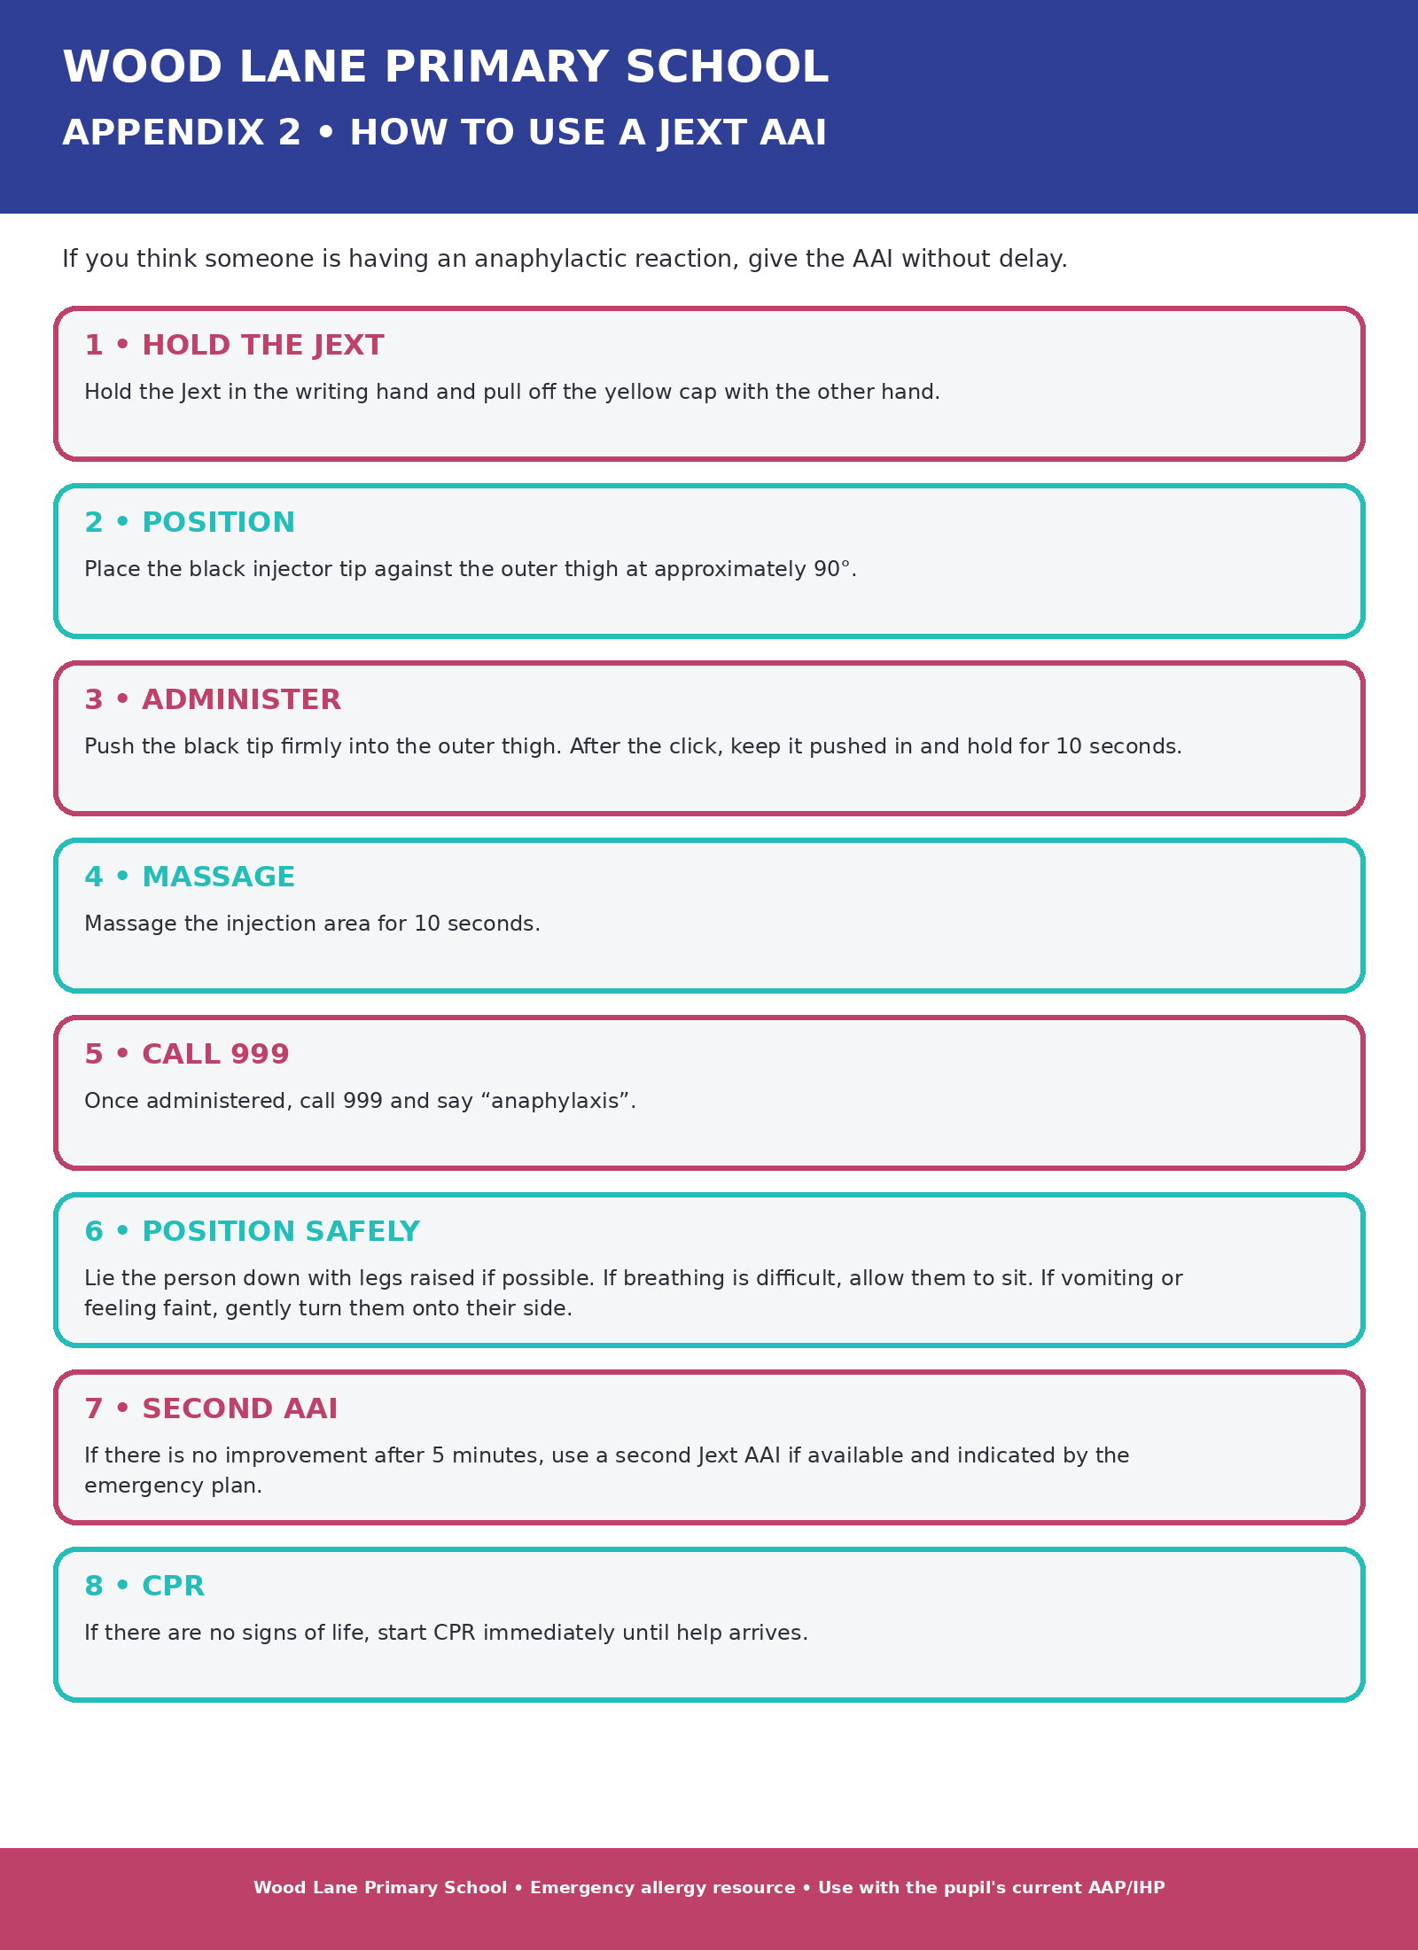

Appendix 3: Allergic reaction flowchart - no adrenaline auto-injector prescribed
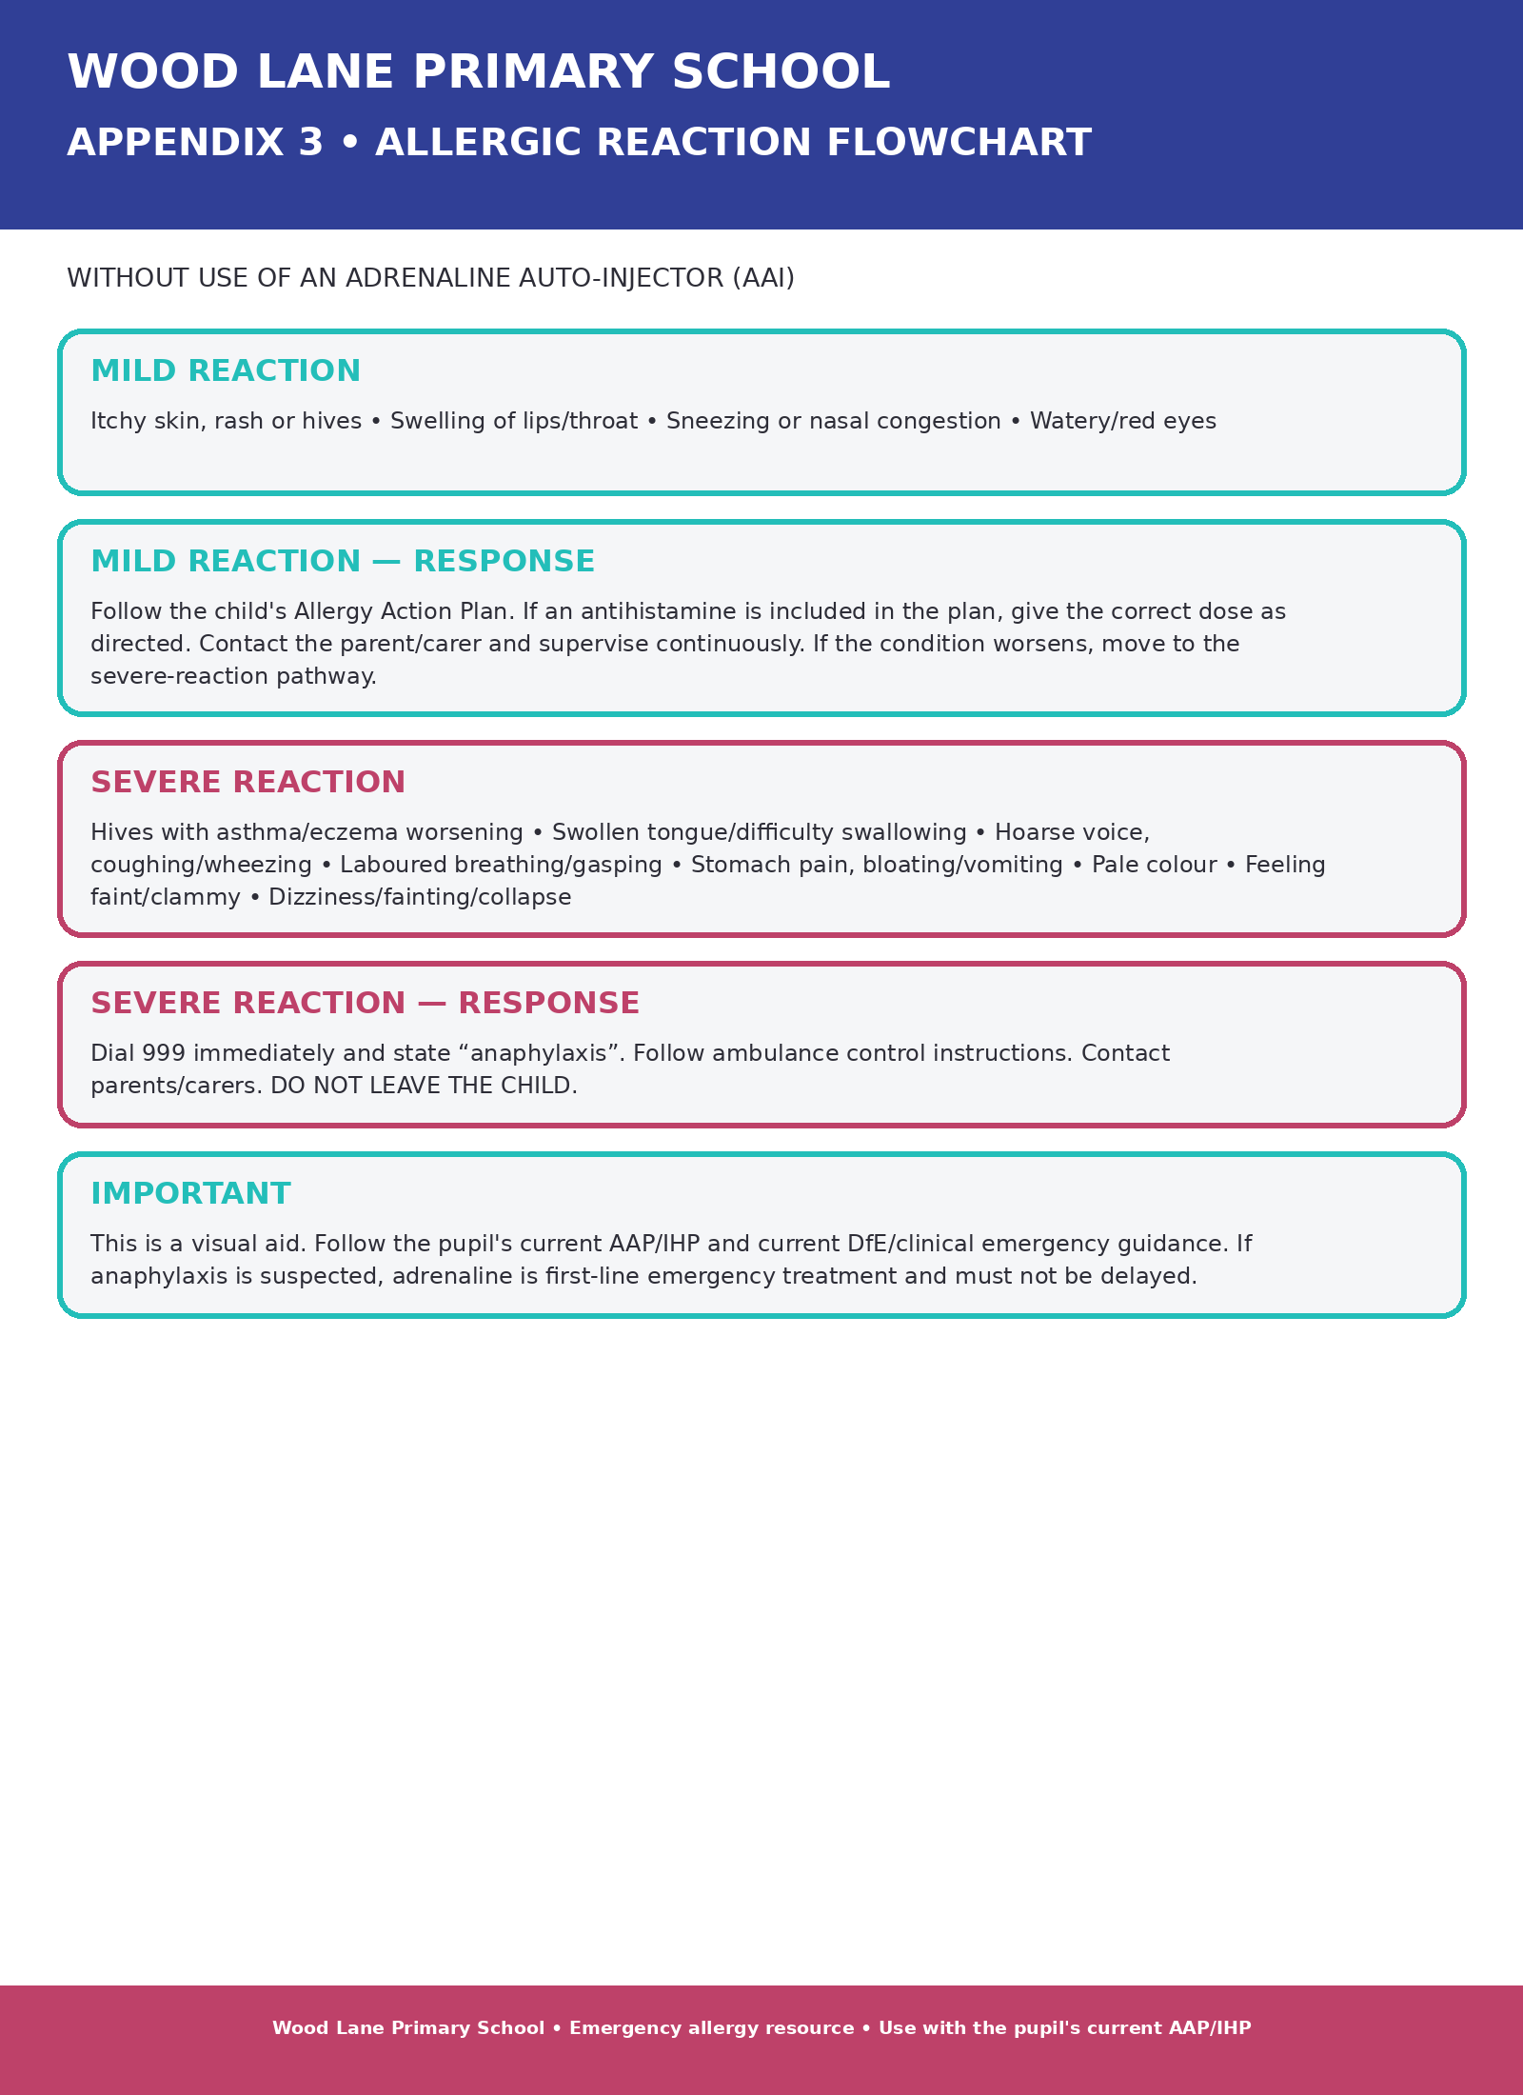

Appendix 4: Allergic reaction flowchart - adrenaline auto-injector prescribed
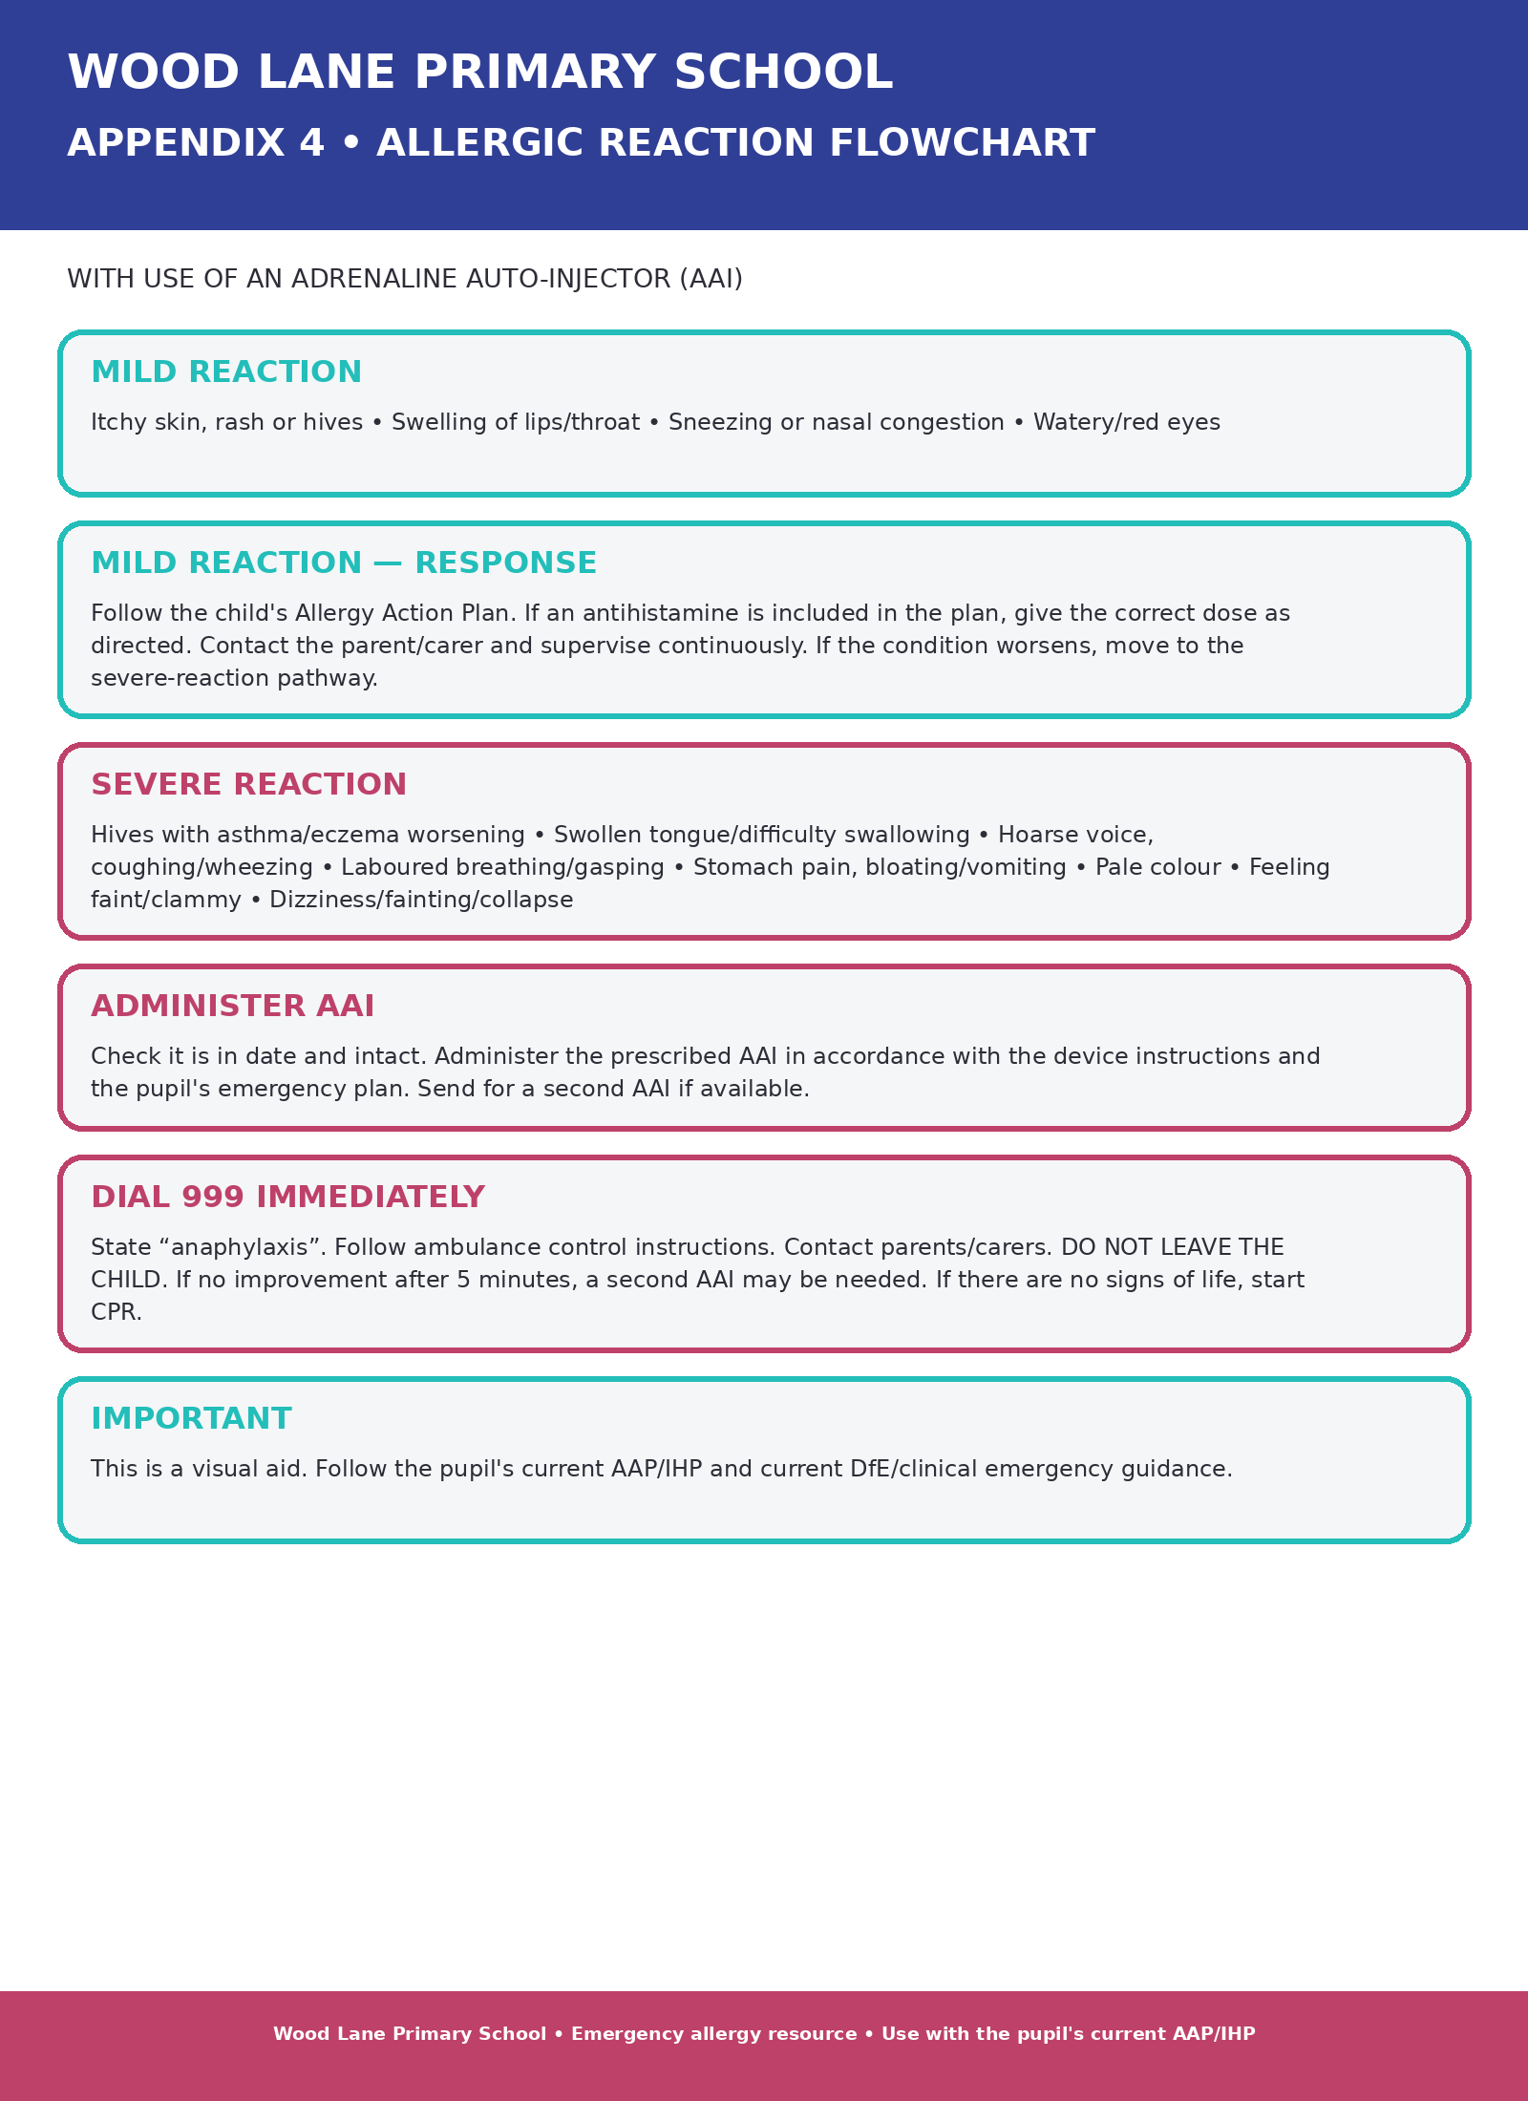

Appendix 5: Information on allergies
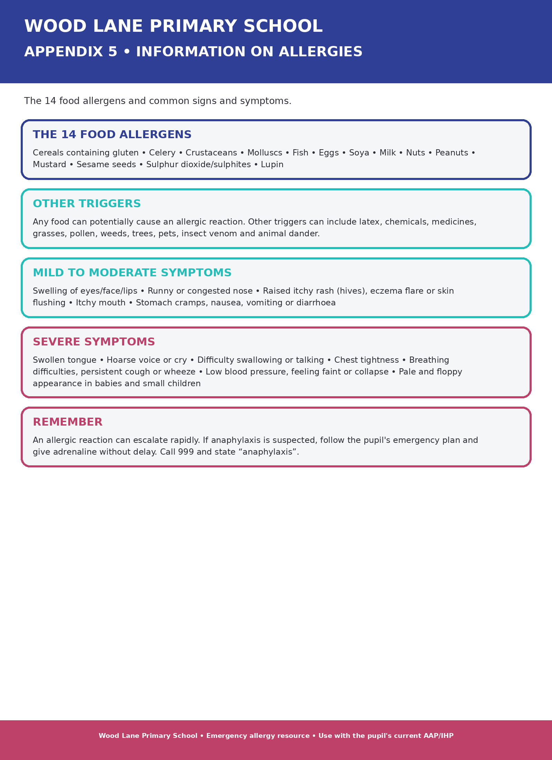

Appendix 6: Support and resources
- NHS guidance on allergies and anaphylaxis.
- Department for Education guidance on supporting pupils with medical conditions at school.
- Department of Health guidance on using emergency adrenaline auto-injectors in schools.
- Allergy UK.
- Anaphylaxis UK.

Document control
Field | Details
Policy owner | Wood Lane Primary School- Mrs Fraser
Approved by | Governing Body- Link Contact (Andrew Buckley)
Approval date | 29/8/26
Review date | July 2027
Version | 1

Source note and legal review
Current legal-reference note: this policy is to be read with the current DfE Allergy safety in schools statutory guidance, the Children's Wellbeing and Schools Act 2026 allergy-safety provisions, KCSIE 2026, applicable health and safety and first-aid legislation, and Wood Lane Primary School's local Health and Safety, Administering Medicines, Medical Conditions, First Aid and Safeguarding policies. Local employer and Staffordshire requirements should be checked before final approval.

