Wood Lane Primary School
Mobile Phone Policy



“BE THE BEST VERSION OF YOURSELF”
September 2026
Approved by: Mr Buckley- Representing the Governing Body
Date: 29/08/26
Next review due by: September 2027

Contents
1. Introduction and aims
2. Roles and responsibilities
3. Use of mobile phones and smart technology by pupils
4. Use of mobile phones and smart technology by staff
Use during trips, visits and off-site activities:
Staff may use a mobile phone during a school trip, visit or other off-site activity where this is necessary for the safe operation of the activity or to fulfil a legitimate school purpose. This includes contacting the school office/Headteacher to report safe arrival at a venue and safe departure from a venue, contacting the school in an emergency, contacting emergency services where required, or communicating with the school about arrangements for the group. Where practicable, these calls should be made away from children and the phone must be used for the school-related purpose only.
Safeguarding concerns on trips or visits: If a member of staff needs to telephone the Headteacher, DSL or school office to report a safeguarding concern, this must be done as soon as reasonably practicable and, wherever possible, away from children and in a way that protects confidentiality. Staff must not delay reporting a safeguarding concern because they are away from school. If the concern requires immediate action, staff should follow the school's safeguarding procedures and contact emergency services where appropriate.
Where possible, the trip leader or designated member of staff should make the required school-related call. Other supervising staff may carry and use a mobile phone where this is necessary for communication, safeguarding or emergency purposes and is consistent with the trip risk assessment.
Personal mobile-phone use outside the designated staff-only space will only be permitted in extreme or exceptional circumstances and must be specifically authorised by the Headteacher.
5. Parents, carers, volunteers, governors, contractors and visitors
6. Safeguarding, online safety, GDPR and data protection
7. Searching, confiscation and sanctions
8. Loss, theft or damage
9. Trips, residentials and outside the school day
10. Reasonable adjustments and exceptional circumstances
11. Monitoring, implementation and review
Appendix 1: Acceptable use agreement for children
Appendix 2: Permission form for an approved exception/trip
Appendix 3: Visitor mobile phone information slip

1. Introduction and aims
1.1 Aims
At Wood Lane Primary School, we recognise that mobile phones and smart technology are part of everyday life for children, families and staff. We also recognise that mobile phones can create safeguarding, behaviour, privacy, data protection and wellbeing risks. This policy sets clear expectations so that the school remains calm, safe and focused on learning.
Our policy aims to:
• Promote safe, responsible and respectful use of mobile phones and smart technology.
• Protect children from online abuse, cyberbullying, exploitation, harmful content, inappropriate contact and other safeguarding risks.
• Protect privacy and personal data, including photographs, video, audio, location information and communications.
• Reduce distraction and disruption during the school day.
• Support the school's Behaviour Policy, Child Protection and Safeguarding Policy, Cyber Security / Online Safety Policy, Prevent / Counter-Extremism Policy and Data Protection arrangements.
• Provide clear and consistent arrangements for pupils, staff, parents, volunteers, governors, contractors and visitors.
1.2 2026 statutory position
From 1 September 2026, Wood Lane Primary School will operate as a mobile-phone-free environment by default. The Department for Education's 'Mobile phones in schools' guidance became statutory on 29 June 2026 and schools are expected to follow it from 1 September 2026. The guidance expects pupils not to have access to their mobile phone throughout the school day, including lessons, the time between lessons, breaktimes and lunchtime. The policy applies to mobile phones and other smart technology with similar communications or recording functionality where the school has decided to include it.
The school will therefore prohibit pupil access to mobile phones throughout the school day, subject only to approved exceptions, reasonable adjustments and specific medical, SEND, safeguarding or other exceptional circumstances. The school's approach is consistent with the 2026 statutory guidance and will be implemented through the Behaviour Policy and this standalone policy.
1.3 Rationale
The safeguarding of pupils is paramount. Mobile phones and similar devices can be used to access and distribute harmful or illegal content, facilitate cyberbullying, enable unwanted contact or exploitation, record or share images without consent, and support online grooming or radicalisation. They can also cause distraction, disruption and pressure on children's wellbeing.
2. Roles and responsibilities
Governing Body
• Ensure the policy is approved, published and reviewed.
• Ensure the policy is aligned with the Behaviour Policy, safeguarding arrangements and the 2026
statutory mobile-phone guidance.
• Ensure appropriate filtering and monitoring arrangements are in place and reviewed in line with
Keeping Children Safe in Education 2026.
Headteacher / Senior Leadership Team
• Implement and consistently enforce the policy.
• Approve any individual exception or reasonable adjustment.
• Ensure staff, pupils and parents understand expectations and sanctions.
• Ensure mobile-phone incidents that indicate a safeguarding concern are referred to the DSL.
• Ensure arrangements for searching and confiscation are consistent with the Behaviour Policy and DfE guidance.
DSL / Deputy DSL
• Consider whether mobile-phone misuse indicates bullying, abuse, exploitation, self-harm,
harmful sexual behaviour, radicalisation or another safeguarding concern.
• Follow the Child Protection and Safeguarding Policy where a concern arises.
• Coordinate with the filtering/monitoring lead and IT provider where online activity is relevant.
All staff
• Model appropriate mobile-phone behaviour.
• Consistently apply the policy.
• Never use a personal phone for personal reasons in front of pupils during the school day, except
where specifically permitted for a legitimate school purpose, emergency or reasonable
adjustment.
• Report safeguarding, data-protection or cyber-security concerns immediately.
3. Use of mobile phones and smart technology by pupils
Pupils should not have access to mobile phones during the school day. Wood Lane Primary School therefore strongly discourages pupils from bringing mobile phones to school.
Where a pupil has an approved need to bring a phone:
• The pupil must hand the phone to a member of staff on arrival, unless an agreed individual
arrangement says otherwise.
• The phone must be switched off and stored securely in the school's designated locked storage in
the Headteacher's office.
• The pupil may collect the phone at the end of the school day or, where appropriate, when
leaving school due to illness.
• Once collected, the phone must remain out of use until the pupil has left the school premises.
• Parents/carers should contact the school office if they need to communicate with a child during
the school day.
Prohibited use includes:
• Making or receiving calls or messages.
• Using social media, messaging, gaming, recording or camera functions.
• Taking photographs, video or audio recordings of pupils, staff or visitors without explicit
authorisation.
• Accessing, creating or sharing harmful, illegal, abusive, discriminatory, sexual or extremist
content.
• Using a phone to bully, threaten, intimidate, impersonate or harass another person.
• Using a phone to cheat, disrupt learning or breach another school policy.
Smartwatches and similar devices
Smartwatches and other wearable or portable devices with similar communications, notification, recording, camera or messaging functions are included within this policy where they create the same risks as mobile phones. A pupil may wear a simple watch that has no prohibited communications or recording functionality, subject to the school's usual arrangements.
4. Use of mobile phones and smart technology by staff
The existing Wood Lane arrangements remain in place and are strengthened to reflect the 2026 DfE expectations that staff should model the mobile-phone-free environment.
• Staff must not use personal mobile phones for personal reasons in front of pupils during the
school day.
• Personal phones should be switched off or placed on silent, out of sight and stored in designated
staff lockers/drawers or approved safe zones.
• Staff lockers are situated in the staffroom and EYFS room; the Headteacher, Office Manager and
Caretaker may use their designated safe zones.
• Staff must not photograph, film or audio-record pupils using personal devices.
• School equipment must be used for authorised photographs, recordings and school
communications.
• Personal mobiles must not be used for work-related purposes unless specifically authorised by
the Headteacher for a defined purpose, such as an approved trip or site-team work.
• Where an authorised work use is necessary, it should take place away from pupils wherever
practicable and pupils must remain supervised by appropriate staff.
• In an emergency, a mobile phone may be used to contact emergency services.
• Staff should use secure passwords, biometric protection and other appropriate security controls
on personal devices used under an approved exception.
• Where a staff member needs access to a phone because of a significant personal or family
circumstance, the Headteacher may approve an individual arrangement, with the phone kept
securely and used away from pupils.
• The DfE recognises that limited legitimate staff use may sometimes be necessary, for example
for multi-factor authentication or issuing homework/rewards/sanctions. Any such use must be
proportionate, authorised and consistent with safeguarding.
Site-team staff may use mobile phones in areas such as voids, lofts or boiler spaces where two-way communication is genuinely required for safe working. Such use must be authorised by the Headteacher and must not create a safeguarding or privacy risk.
Family emergencies and extreme circumstances: Staff may request permission to keep their mobile phone close by during the school day only where there is an extreme family emergency or other exceptional circumstance that makes this necessary. Such an arrangement is not automatic and must be agreed in advance by the Headteacher. Where permission is granted, the Headteacher will agree the appropriate conditions, including where the phone is kept, how it may be used and how disruption to pupils and safeguarding risks will be minimised. Where practicable, use should still take place away from pupils and the front office.
5. Parents, carers, volunteers, governors, contractors and visitors
All visitors, volunteers, governors and contractors are expected to follow the school's expectations for mobile-phone use while on the premises. Where a legitimate work purpose requires phone access, the visitor must inform the school and use the device in a safe area or under appropriate supervision.
Parents and carers should not use mobile phones in school where this could distract from safeguarding or learning. Parents/carers should not photograph or record other people's children. Any photography permitted by the school at a celebration or event must follow the school's instructions, be supervised where appropriate and must not be uploaded to social media or otherwise shared beyond the agreed personal purpose.
Parents/carers who need to contact their child during the school day should contact the school office. The school will relay urgent messages promptly and will provide appropriate access to communication where an individual safeguarding, medical, SEND or other exceptional need has been agreed.
6. Safeguarding, online safety, GDPR and data protection
Mobile-phone use is part of the school's wider online-safety and safeguarding framework. KCSIE 2026 requires schools to consider online risks and maintain effective filtering and monitoring arrangements. Mobile phones may provide access to content or applications that are not visible through school filtering, so the school will teach pupils about safe use and will act on concerns appropriately.
• Photographs, videos, audio recordings, messages, contact details and location information may
constitute personal data and must be handled in accordance with the school's data protection
arrangements.
• Personal devices must not be used to store or transmit pupil safeguarding information unless
specifically authorised and protected.
• Personal or confidential information must not be entered into public AI tools or unapproved
apps.
• Suspected loss, theft, unauthorised disclosure or compromise of personal data must be reported
immediately under the school's data-breach procedure.
• If a mobile-phone incident indicates a safeguarding concern, staff must inform the DSL and
follow the Child Protection and Safeguarding Policy.
• If a phone contains suspected harmful sexual images, threats, exploitation material,
terrorist/extremist material or evidence of an offence, staff must not unnecessarily copy,
forward or circulate it. The matter must be referred to the DSL and, where appropriate, the
police in accordance with safeguarding procedures.
• The school will consider online radicalisation and extremist content under its Prevent / Counter-
Extremism Policy.
7. Searching, confiscation and sanctions
Mobile phones are identified as items that may be searched for under the school's Behaviour Policy. Headteachers or authorised staff may use statutory search powers where there are reasonable grounds to suspect that a pupil has a prohibited item or an item identified in the school rules as searchable. Staff will follow the DfE Searching, Screening and Confiscation guidance.
Where a pupil breaches this policy:
• The phone may be confiscated as a proportionate disciplinary sanction.
• Parents/carers may be contacted and, where appropriate, asked to collect the phone.
• Repeated breaches may result in further sanctions under the Behaviour Policy.
• The school will consider the pupil's age, SEND, medical needs, individual circumstances and
whether a safeguarding concern is present before determining a sanction.
• If the behaviour suggests that the pupil may be experiencing harm or may be at risk of harm, the
DSL will be informed.
Confiscation will be handled lawfully and proportionately. Staff will take reasonable care of confiscated devices. The school will not routinely access the contents of a device simply because it has been confiscated; where searching the device is necessary and lawful, staff will follow the relevant statutory guidance and safeguarding procedures.
8. Loss, theft or damage
Pupils are responsible for any device they bring to school. The school discourages pupils from bringing mobile phones and cannot guarantee the security of personal devices. Where the school has required or expressly approved a phone to be handed in, it will take reasonable steps to store the device securely. Any loss, theft or damage should be reported immediately.
Staff will act in accordance with the law and school procedures when confiscating or storing a device. Parents/carers should not contact individual staff members about confiscated phones; queries should be directed to the school office or Headteacher.
9. Trips, residentials and outside the school day
The existing Wood Lane position is retained: pupils are not permitted to have mobile phones on school trips or residentials unless the Headteacher has approved an individual exception or the trip risk assessment provides otherwise.
• The school will assess the educational, safeguarding and travel risks of mobile-phone use for
each trip.
• Where phones are permitted outside the normal school day, expectations must be
communicated to pupils and parents in advance.
• The school may require phones to be handed to staff or stored securely during activities.
• On residentials, the school will make appropriate arrangements for pupils to contact
parents/carers where needed without undermining safeguarding or the educational experience.
• Pupils travelling to and from school should follow the school's agreed arrangements; where
phone is needed for travel safety, the phone should remain inaccessible during the school day.
10. Reasonable adjustments and exceptional circumstances
The school will maintain a mobile-phone-free environment by default but will comply with its other legal duties. This includes the Equality Act 2010 duty to make reasonable adjustments and duties relating to pupils with medical conditions.
An exception may be approved where access is necessary because of a pupil's disability, medical condition, safeguarding circumstances, caring responsibilities or another exceptional individual need. For example, a pupil may require a mobile phone linked to a continuous glucose monitor.
An exception does not automatically mean unrestricted access. The school will normally specify the purpose, times, location, supervision and conditions of use. Arrangements may be recorded in the pupil's individual healthcare plan, support plan, safeguarding plan or other appropriate school record.
Parents/carers should discuss a potential exception with the Headteacher or DSL before the pupil brings or uses the device. The school will review arrangements where circumstances change.
11. Monitoring, implementation and review
• The policy will be published and communicated to staff, pupils and parents.
• Pupils will be reminded of the expectations at the start of each school year and at appropriate
intervals.
• The policy will be reviewed alongside the Behaviour Policy, Child Protection and Safeguarding
Policy, Cyber Security / Online Safety Policy and Prevent / Counter-Extremism Policy.
• The school will monitor mobile-phone incidents, sanctions, exceptions and safeguarding
concerns to identify patterns and adjust provision where necessary.
• Governors will receive appropriate assurance that the policy is being implemented consistently.
• The policy will be reviewed annually and sooner if legislation, statutory guidance, safeguarding
risks or school circumstances change.
This policy takes account of the Department for Education's statutory Mobile phones in schools guidance (updated 29 June 2026), Keeping Children Safe in Education 2026, Behaviour in schools guidance, Searching, Screening and Confiscation guidance, relevant data-protection guidance and the school's wider safeguarding and cyber-security arrangements.

Appendix 1: Acceptable use agreement for children
I understand that Wood Lane Primary School is a mobile-phone-free school during the school day.
• I will not use or access a mobile phone, smartwatch or similar device during the school day unless I have an approved exception.
• If I need to bring a phone to school, I will hand it to staff on arrival and collect it at the agreed time.
• I will not use a device to take photographs, videos or recordings of other people without permission.
• I will not use a device to bully, threaten, embarrass or harm anyone.
• I will not access or share harmful, illegal, sexual, extremist or other inappropriate content.
• I understand that a breach of this agreement may result in the phone being confiscated and other sanctions under the Behaviour Policy.
• I know that if something online makes me worried or unsafe, I can tell a trusted adult in school.
Pupil name: ______________________________
Signature: _______________________________
Date: ___________________________________
Parent/carer signature: ___________________

Appendix 2: Permission form for an approved exception / trip
Pupil name: ______________________________
Reason for exception: _____________________
Device: __________________________________
Purpose of use: ___________________________
Approved times/location: __________________
Storage arrangements: ____________________
Start date: __________ Review date: ________
Approved by Headteacher: _________________
Parent/carer acknowledgement: ____________
The exception is limited to the agreed purpose and does not provide unrestricted access to the device. The arrangement may be withdrawn or amended if circumstances change or the device is misused.

Appendix 3: Visitor mobile phone information slip
Welcome to Wood Lane Primary School. For safeguarding, privacy and data-protection reasons, please do not use your personal mobile phone to photograph, record or communicate with pupils while on site unless the school has expressly authorised this.
If you require your phone for a legitimate work purpose, please inform the school office and follow the agreed arrangements. Visitors must not photograph or record children or staff without appropriate authorisation.
Visitor name: _____________________________
Organisation: _____________________________
Date: ____________________________________
Signature: ________________________________
Appendix 4: Mobile Phone Policy Poster
Staff, pupil and visitor summary
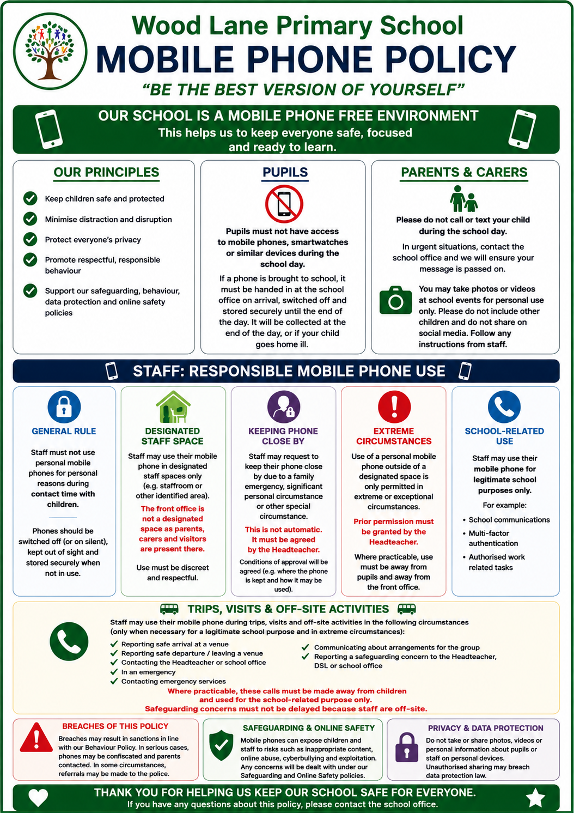
Motto: “BE THE BEST VERSION OF YOURSELF”

